**Geography 150 Lab 4: Adiabatic processes and moisture in the atmosphere**

Assume that a parcel or mass of air is forced up and rises over a ***4000 meter (13,100 feet) high mountain*** (shown below). The height of this mountain would be intermediate between Mt. Olympus (elevation: 7980 feet or 2432 meters) in the Olympic mountains and Mt. Rainier (elevation: 14,410 feet or 4392 meters) in the Cascade mountains. This process, called the orographic effect or orographic lifting, is characteristic of our region as air moves inland off the ocean and encounters mountain ranges.

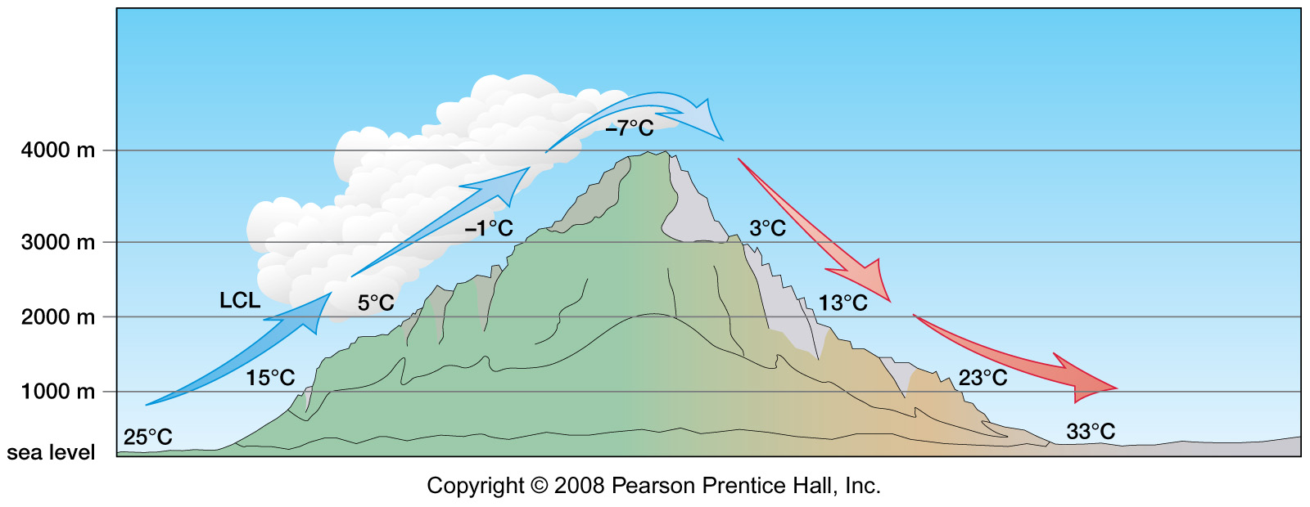

The ***initial temperature of the parcel of air at sea level is 25 degrees Celsius*** or 77 degrees Fahrenheit. The ***final temperature of the air at sea level is 33 degrees Celsius*** or 91.4 degrees Fahrenheit. These temperatures might be quite typical of a summer day here in western Washington and in eastern Washington east of the Cascade Range.

The ***lifting condensation level (LCL) of the parcel is 2000 meters*** (6550 feet). The ***DAR or dry adiabatic rate is 10 degrees C/1000 meters*** or 5.5 degrees F/1000 feet. The ***SAR or saturated adiabatic rate is 6 degrees C/1000 meters*** or 3.3 degrees F/1000 feet. Assume that condensation begins at 100% relative humidity and no evaporation adds water to the parcel as it descends the lee hand side of the mountain.

1. Why is the parcel of air warmer at sea level on the lee side (to right) than it was at sea level on the windward side (to left)? What is the source of the heat energy?
2. On the windward side of the mountain, is the relative humidity of the parcel increasing or decreasing as it rises from sea level to 2000 meters (6550 feet)? Why?
3. On the lee side of the mountain, is the relative humidity of the parcel increasing or decreasing as it descends from 4000 meters (13,100 feet) to sea level? Why?

Consider the chart of Saturation mixing ratios or ***water vapor capacity*** (below) and interpolate from the chart as needed. The red line is the maximum amount of water vapor that can be in the air at the given temperatures. As temperature of the air increases (to right) the water vapor capacity of the air increases. Assume that condensation begins at 100% relative humidity and that no moisture is added by evaporation as the parcel descends.

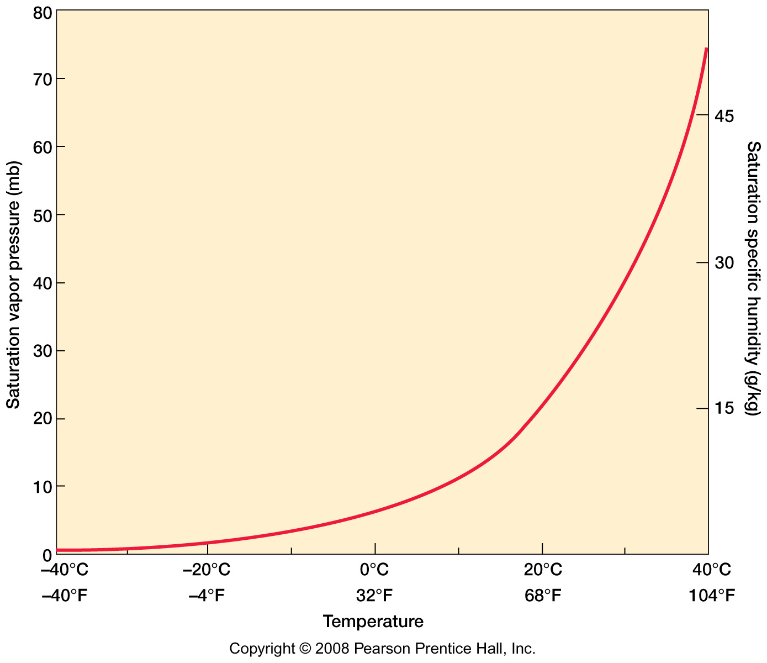

1. On the windward side of the mountain, should the relative humidity of the parcel change as it rises from 2000 meters (6550 feet) to 4000 meters (13,100 feet)? Why?
2. As the air rises up the windward side of the mountain:

What is the capacity (saturation mixing ratio) of the rising air at 2000 meters in g/kg?

What is the capacity of the air at 4000 meters in g/kg?

1. What is the capacity of the air after it has descended back down to sea level on the lee side of the mountain in g/kg?
2. Assuming that no water vapor is added as the parcel descends on the lee side of the mountain to sea level, is the water vapor content (the mixing ratio) of the parcel higher or lower than before it began to rise over the mountain? Why?
3. What is the lifting condensation level (LCL) of the parcel after it has descended to sea level on the lee side of the mountain?